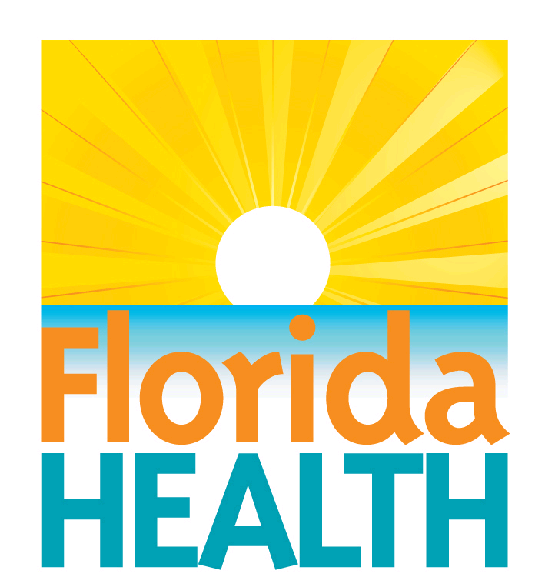
VOLUNTEER HEALTH SERVICES

EMMANUEL PROJECT ST. JOHNS COUNTY, FL

VOLUNTEER HEALTH CARE PROVIDER PROGRAM (VHCPP)

APPLICATION for SOVEREIGN IMMUNITY CONTRACT

Provider’s Full Name: (LAST) (FIRST) (MI)

Address:
(Street) (City) (State) (Zip)

Phone Number: ( ) E-mail Address:
(Include Area Code) (Optional)

Occupation: Specialty: FL License Number:
It is recommended by the Department of Health that individual providers, applying for a VHCPP contract for sovereign immunity protection, and who are affiliated with a Professional Association, (P.A.)/Group, also establish a Sovereign Immunity contract to protect the P.A/Group and its employees.

Please indicate if you would like a Corporate contract if you are affiliated with a P.A/Group.

CHECK APPROPRIATE RESPONSE, SIGN AND DATE THE FORM

Yes No

(If Yes, please complete the following information)

Signature: Date:

P A/Group Corporation Name:

Printed Name of Corporate Officer/Director with Contract Authority:

Business Address: (Street) (City) (State) (Zip)
Mailing Address ( if different from above address):
Phone Number: (________) ______-__________ FEI or Document Number:___________________________________

IN ORDER TO PROTECT CLIENTS A ROUTINE CHECK OF THE FLORIDA MEDICAL LICENSE AND CORPORATION NAME WILL BE MADE
THROUGH THE FLORIDA DEPT OF HEALTH MEDICAL QUALITY ASSURANCE AND/OR THE FLORIDA DIVISION OF CORPORATIONS
License/Corporation Verification (for DOH use only)
Individual
Current Florida Health Professional License? Yes _____ No _____
License Status “Clear and Active? Yes _____ No _____
Corporation:
Active and Registered Florida Corporation? Yes _____ No _____

Verification Completed By: (Signature of VHCPP Regional Coordinator) Date

